|  |  |
| --- | --- |
| **Name** | **Raguman J** |
| **Reg No** | **621421106036** |
| **Department** | **ECE** |
| **Year** | **III** |
| **College Name** | **Maha Barathi Engineering College** |
| **Group** | **IoT – Noise Pollution Monitoring** |

**Noise Pollution Monitoring**

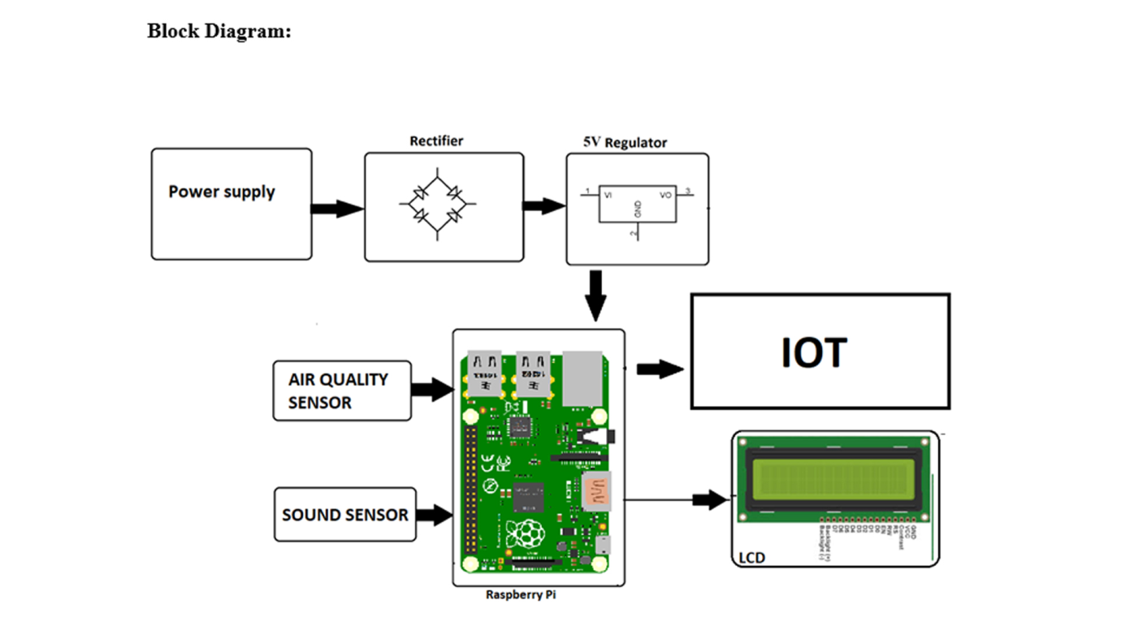

**Working**

IoT-based noise pollution monitoring systems utilize sensors, connectivity, and data analysis to monitor and analyze noise levels in real-time. Here is a general overview of how they work:

1. Sensors: Noise pollution monitoring systems are equipped with sensors that measure sound levels. These sensors can be placed in various locations to capture noise data from different areas.

2. Connectivity: The monitoring system is connected to the internet through Wi-Fi or other communication protocols. This allows the system to transmit and receive data in real-time.

3. Data collection: The sensors continuously collect noise data, including sound levels and frequency information. This data is then sent to a cloud-based platform for storage and analysis.

4. Cloud-based platform: The collected noise data is stored and processed in a cloud-based platform. Advanced analytics algorithms can be applied to analyze the data and identify patterns, trends, and anomalies.

5. User interface: The monitoring system may have a user interface that displays real-time noise levels and provides access to historical data. This interface allows users to monitor noise levels and identify potential noise pollution hotspots.

6. Alerts and notifications: Based on predefined thresholds or user-defined criteria, the monitoring system can generate alerts and notifications when noise levels exceed certain limits. These alerts can be sent to facility managers or relevant authorities for further action.

7. Data visualization and reporting: The cloud-based platform can provide visualizations of noise data, such as graphs and maps, to help users understand the noise pollution situation. Reports can also be generated to provide insights and support decision-making processes.

8. Integration with other systems: IoT-based noise pollution monitoring systems can be integrated with other systems, such as smart city platforms or environmental management systems. This integration allows for a holistic approach to managing noise pollution and enables coordinated actions across different domains.

By leveraging IoT technology, noise pollution monitoring systems provide valuable insights into noise levels, helping to identify sources of excessive noise and implement measures to mitigate noise pollution.